|  |  |  |  |  |  |
| --- | --- | --- | --- | --- | --- |
| **Problem**  **Statement (PS)** | **I am**  **(Customer)** | **I’m trying to** | **But** | **Because** | **Which makes me feel** |
| PS-1 | Journalist | Gather information | Unable to get informati on based on  interests | There are vast area of news that are available | Annoyed |
| PS-2 | Stock investors | Want to know the current stock price | It is difficult to find it in | Because a large set of news are covered | Skeptical on my decisions |

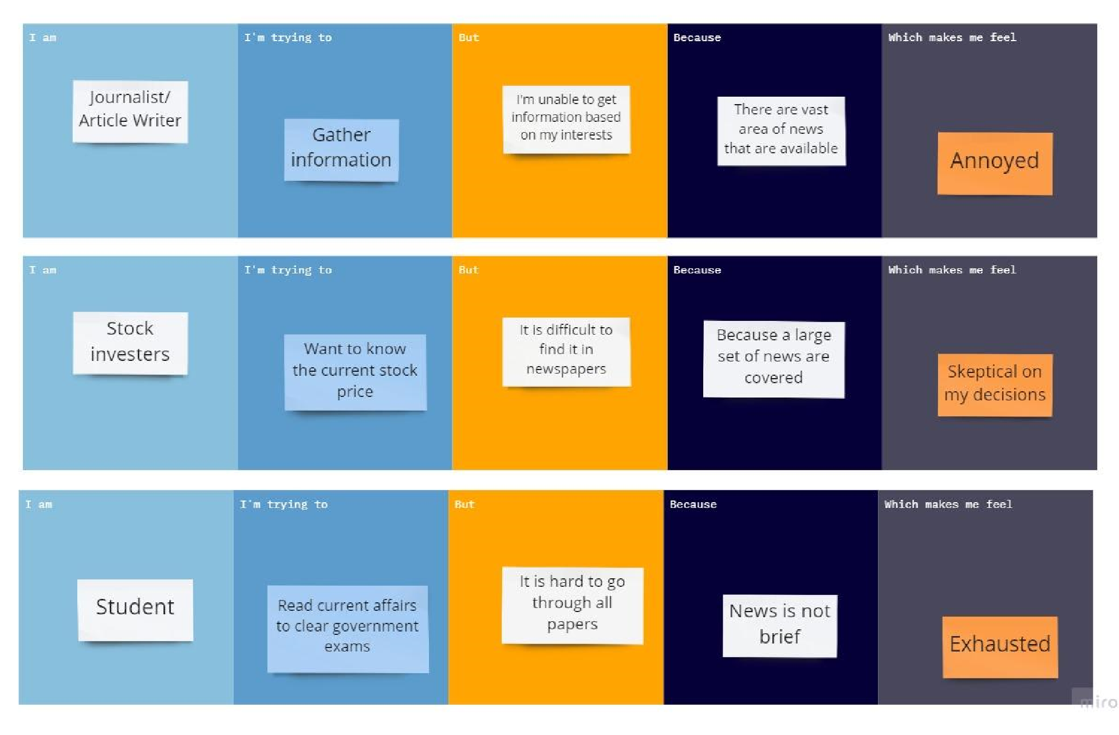**Ideation Phase Problem Statements**

|  |  |
| --- | --- |
| Date | 19 September 2022 |
| Team ID | PNT2022TMID04471 |
| Project Name | Project - News Tracker Application |
| Maximum Marks | 2 Marks |

**Customer Problem Statement:**

The lives of people have been busy and they don’t have time to read news or know any current events. Finding newspapers and reading it through has become a tedious task.

|  |  |  |  |  |  |
| --- | --- | --- | --- | --- | --- |
|  |  |  | newspap  ers |  |  |
| PS-3 | Student | Read current affairs to clear government exams | It is hard to go through all papers | News is not brief | Exhausted |